|  |
| --- |
| Close-up image showing the leaf-sides of two oversized books side-by-side on a bookshelf, with additional books in soft focus background |
| Software Design and Architecture  ONLINE SHOPING SYSTEM |
| |  |  |  | | --- | --- | --- | | Muhammad Hashir (FA22-BSE-031) | 9/14/24 | Lab Task 02 | |

USE CASE:

FULLY DRESSED USE CASE:(Make Purchase):

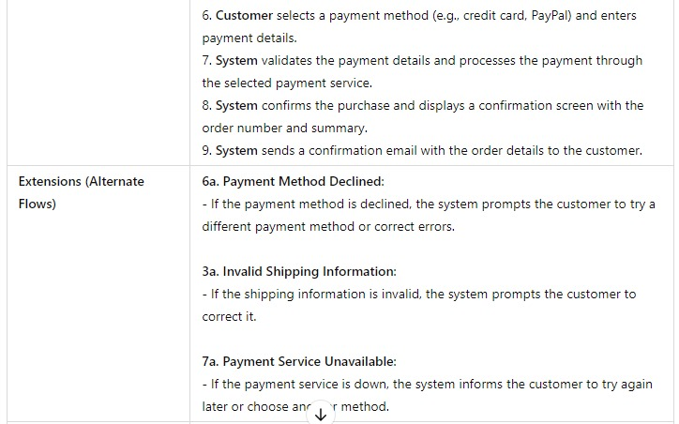

SEQUENCE DIAGRAM:

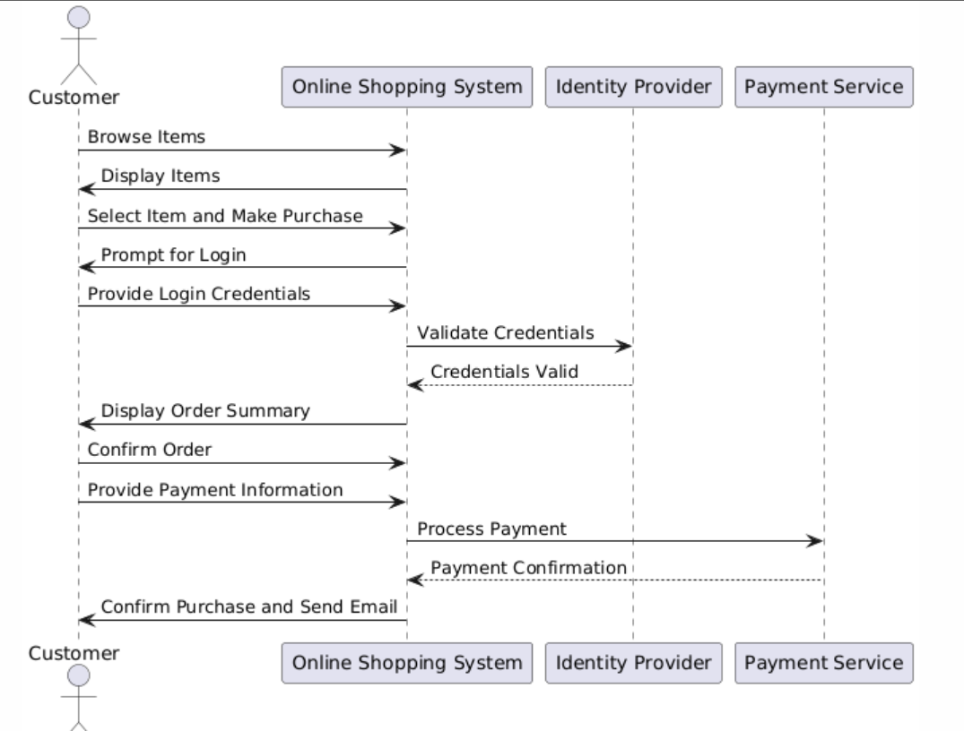

CLASS DIAGRAM:

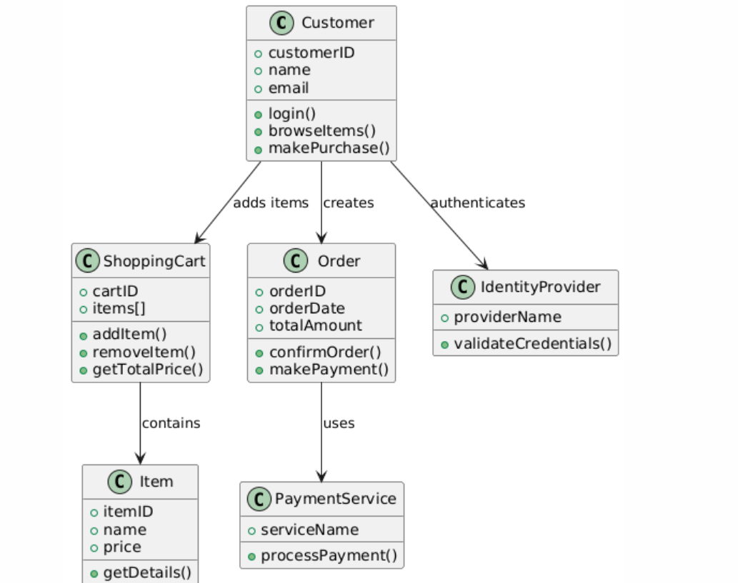

COMMUNICATION DIAGRAM:

